1. Barchart
   1. Erens Method

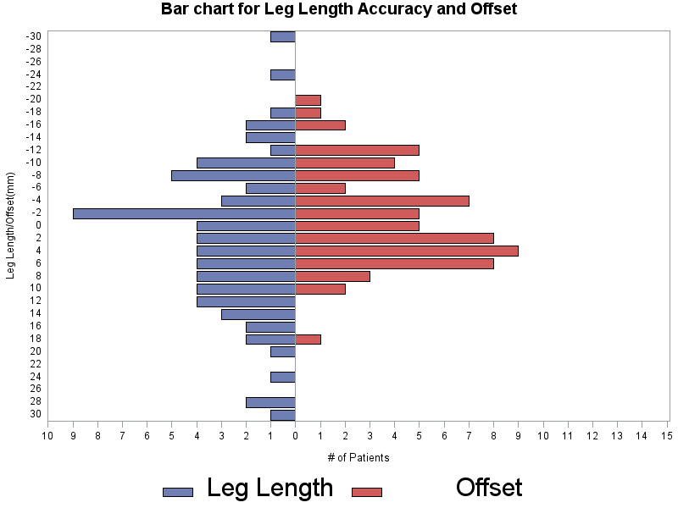

**There are 90% measurements within -16.7 to 23.8 (Leg Length), and -15.4 to 8.4 (Offset).**

| **Quantile** | **Leg Length** | **Offset** |
| --- | --- | --- |
| **100% Max** | 30.7 | 18.8 |
| **99%** | 30.7 | 18.8 |
| **95%** | 23.8 | 8.4 |
| **90%** | 16.3 | 6.8 |
| **75% Q3** | 9.6 | 4.4 |
| **50% Median** | 1.0 | -0.6 |
| **25% Q1** | -6.2 | -7.4 |
| **10%** | -11.2 | -11.6 |
| **5%** | -16.7 | -15.4 |
| **1%** | -30.7 | -19.0 |
| **0% Min** | -30.7 | -19.0 |

* 1. Bradybury Method:

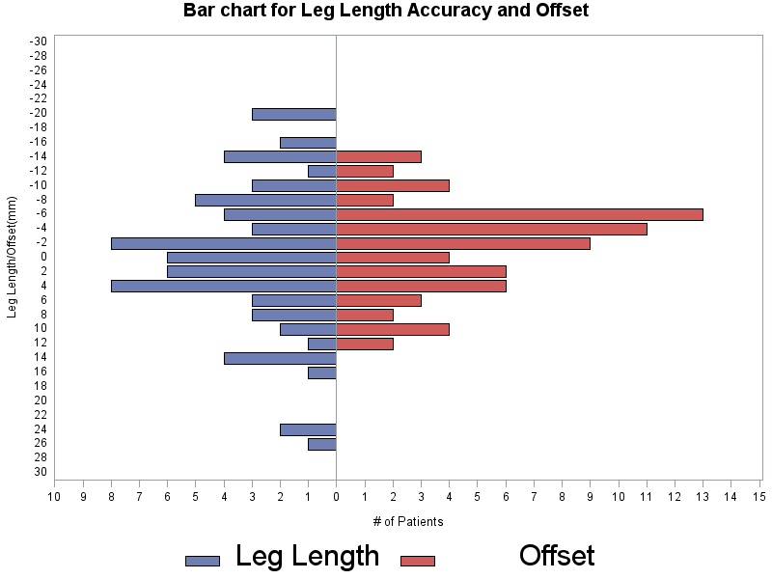

**There are 90% measurements within -16.1 to 16.0 (Leg Length), and -12.0 to 9.6 (Offset).**

| **Quantile** | **Leg Length** | **Offset** |
| --- | --- | --- |
| **100% Max** | 25.9 | 12.4 |
| **99%** | 25.9 | 12.4 |
| **95%** | 16.0 | 9.6 |
| **90%** | 13.2 | 8.0 |
| **75% Q3** | 4.8 | 2.2 |
| **50% Median** | -0.5 | -2.8 |
| **25% Q1** | -7.4 | -5.3 |
| **10%** | -13.7 | -9.8 |
| **5%** | -16.1 | -12.0 |
| **1%** | -19.8 | -13.8 |
| **0% Min** | -19.8 | -13.8 |

1. Mean and Standard Deviation:

| **Method** | **Variable** | **N** | **Mean** | **Std Dev** | **Std Error** | **Median** | **Minimum** | **Maximum** | **Lower Quartile** | **Upper Quartile** |
| --- | --- | --- | --- | --- | --- | --- | --- | --- | --- | --- |
| **Erens** | |  | | --- | | **lesser** | | **greater** | | **offset** | | |  | | --- | | 69 | | 71 | | 68 | | |  | | --- | | 1.9 | | 2.0 | | -1.4 | | |  | | --- | | 8.8 | | 12.0 | | 7.5 | | |  | | --- | | 1.1 | | 1.4 | | 0.9 | | |  | | --- | | 1.8 | | 1.0 | | -0.6 | | |  | | --- | | -17.4 | | -30.7 | | -19.0 | | |  | | --- | | 21.2 | | 30.7 | | 18.8 | | |  | | --- | | -4.2 | | -6.2 | | -7.4 | | |  | | --- | | 6.6 | | 9.6 | | 4.4 | |
| **Bradybury** | |  | | --- | | **lesser** | | **greater** | | **offset** | | |  | | --- | | 71 | | 70 | | 71 | | |  | | --- | | 0.4 | | -0.3 | | -1.7 | | |  | | --- | | 7.6 | | 10.1 | | 6.2 | | |  | | --- | | 0.9 | | 1.2 | | 0.7 | | |  | | --- | | 0.4 | | -0.5 | | -2.8 | | |  | | --- | | -15.5 | | -19.8 | | -13.8 | | |  | | --- | | 22.2 | | 25.9 | | 12.4 | | |  | | --- | | -4.6 | | -7.4 | | -5.3 | | |  | | --- | | 5.0 | | 4.8 | | 2.2 | |

1. Mean Difference:
   1. Leg Length(greater)

| **Method** | **N** | **Mean** | **95% CL Mean** | | **Std Dev** | **Std Err** |
| --- | --- | --- | --- | --- | --- | --- |
| **Erens** | 71 | 2.0 | -0.9 | 4.8 | 12.0 | 1.4 |
| **Bradybury** | 70 | -0.3 | -2.7 | 2.1 | 10.1 | 1.2 |
| **Diff (Erens-Bradybury)** |  | 2.2 | -1.4 | 6.0 | 11.1 | 1.9 |

* 1. Offset

| **Method** | **N** | **Mean** | **95% CL Mean** | | **Std Dev** | **Std Err** |
| --- | --- | --- | --- | --- | --- | --- |
| **Erens** | 68 | -1.4 | -3.2 | 0.4 | 7.5 | 0.9 |
| **Bradybury** | 71 | -1.7 | -3.2 | -0.2 | 6.2 | 0.7 |
| **Diff (Erens-Bradybury)** |  | 0.3 | -2.0 | 2.6 | 6.9 | 1.2 |

1. Wilcoxon-Mann-Whitney test

P value=0.2298 to test leg length between two methods.

P value=0.4737 to test offset between two methods.

This is a nonparametric method without the assumption of normal distribution of the test variables.

For two sample t -test, the p values will be:

P value=0.2307 to test leg length between two methods.

P value=0.8078 to test offset between two methods.